📊 Central Limit Theorem
Practical Implementation Task

ES111 – Probability and Statistics
Spring 2025

Submitted To:
Professor Tahir Naseem

Submitted By:
 | Student Name | Student Reg # | Student Degree
Student-1 | Shayan Rizwan | 2024585 | BSCE



- Code

import datetime
import numpy as np
import pandas as pd
import seaborn as sns
import matplotlib.pyplot as plt
import os
import statistics as stat

# Debug: Confirm files are together
# print("Files in folder:", os.listdir())

# Load the CSV (same directory)
d1 = pd.read_csv(r"D:\2ND SEMESTER\Second-Semester\A1-102L\Related Topics\ES111 Project\IndianHousePrices.csv")
# print(d1.head())

# Preview data: check for the number of rows and columns in the data frame;
# print('Dataset has: \n', d1.shape[0], ' records\n', d1.shape[1], ' columns')

# To check for the type of variable of each column;
# print(d1.dtypes)

# Extract the 'Price' column as the target variable;
# The head() function in Pandas is used to quickly inspect the first few rows of a DataFrame or Series.
# column_data = d1['Price'].head(10)
column_data = d1['Price']
# print(column_data)

# Now that the 'Price' column has been extracted, we randomly draw a sample of size n = 10, from the price column;
# Sample size (sample_size) = 10
# Num. of samples (num_samples) = 1000

num_samples = 1000
sample_size = 1000

# TEST RUN:
# Randomly draw a sample of size N = 10 from the Price column:
print("Randomly drawn values: ")
price_sample = np.random.choice(column_data, sample_size, replace = False)
print(price_sample)

# Compute the sample mean (x̄);
sample_mean = stat.mean(price_sample)
print("Sample Mean (x̄): ", sample_mean)

# Calculate the population mean (μ);
pop_mean = stat.mean(column_data)
print("Population mean (μ): ", pop_mean)

print("As the sample size increases; the sample mean (x̄) converges to the population mean (μ).\n")

# Calculate the population standard deviation (σ);
pop_stdev = stat.pstdev(column_data)
print("Population Standard Deviation: ", pop_stdev)

# The population mean and population standard deviation remain constant because they are calculated from the entire dataset.
# Drawing different samples or changing the sample size does not affect these values—they are fixed characteristics of the population.

z_vals = []
for i in range(num_samples):
current_sample = np.random.choice(column_data, sample_size, replace = False)
samp_mean = stat.mean(current_sample)
compute_z = (samp_mean - pop_mean) / (pop_stdev / np.sqrt(sample_size))
z_vals.append(compute_z)

# Create the plot

plt.figure(figsize=(10, 6))

# Plot the histogram of property prices (scaled)
sns.histplot(z_vals, bins=30, kde = True, color='skyblue')

plt.xlabel("Z-Value")
plt.ylabel("Frequency")
plt.title("Sampling Distribution of Z for N = 1000")
plt.grid(True)
plt.show()

- Plots

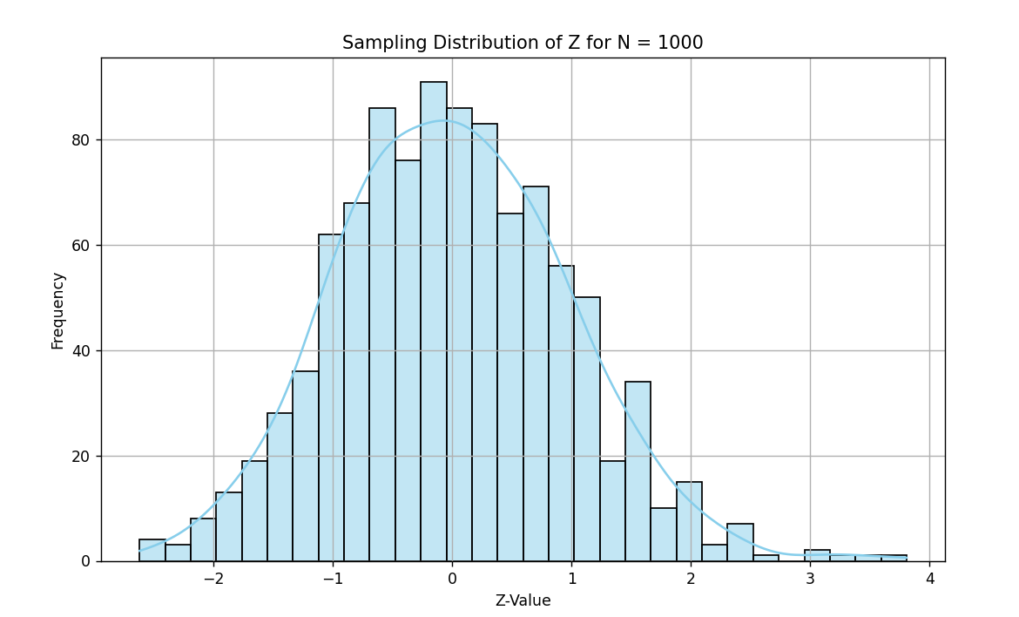
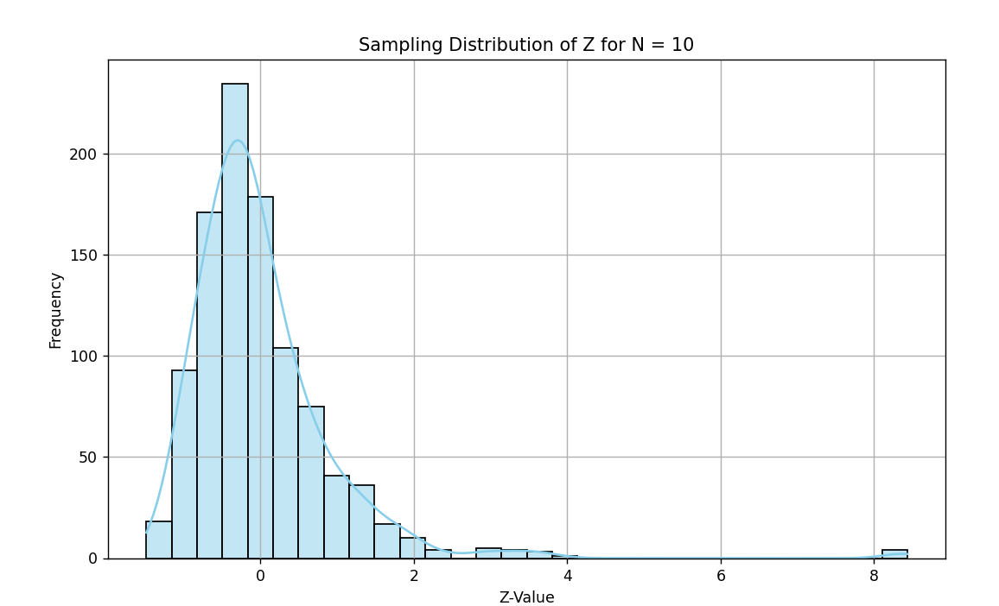

Q. What do you observe about the spread and shape of the z-value distribution as N increases?

As sample size N increases (from 10 to 1000), the spread (standard deviation) of the sampling distribution decreases.
The shape becomes more sharply peaked and closely resembles a normal distribution.
For small N, the histogram is wider and more variable (more spread out); for large N, it is narrower and more concentrated around 0.

Q. How does this confirm what the Central Limit Theorem predicts?
The CLT states that as the sample size increases, the sampling distribution of the sample mean approaches a normal distribution, regardless of the shape of the population distribution.
My observation (narrower, more normal-shaped histogram for N=1000) confirms this.

Resources:
“The Central Limit Theorem – With Examples In Python” Youtube, uploaded by Jon Krohn, 16th March, 2020,
https://www.youtube.com/watch?v=1p8pBje5SOE

Python – Central Limit Theorem
GeeksforGeeks
https://www.geeksforgeeks.org/python-central-limit-theorem/

